HOME AUTOMATION SYSTEM

By Shreerang Mhatre

Introduction:

In the age of technology and the Internet of Things (IoT), the concept of home automation is becoming increasingly popular. It offers homeowners the convenience of controlling various aspects of their home, enhancing energy efficiency, and improving security. This project presents a practical example of a home automation system using an Arduino UNO, multiple sensors, and actuators. It combines various functionalities, including lighting control, motion detection, door control, gas leak detection, and automatic night lighting. The system not only showcases the potential of IoT in home automation but also offers real-world applications for improved quality of life and safety.

**Arduino:**

Arduino is an open-source platform used for building electronics projects. Arduino consists of both a physical programmable circuit board (often referred to as a microcontroller) and a piece of software, or IDE (Integrated Development Environment) that runs on your computer, used to write and upload computer code to the physical board.

The Arduino platform has become quite popular with people just starting out with electronics, and for good reason. Unlike most previous programmable circuit boards, the Arduino does not need a separate piece of hardware (called a programmer) in order to load new code onto the board -- you can simply use a USB cable. Additionally, the Arduino IDE uses a simplified version of C++, making it easier to learn to program. Finally, Arduino provides a standard form factor that breaks out the functions of the micro-controller into a more accessible package.

**What Does it Do?**

The Arduino hardware and software was designed for artists, designers, hobbyists, hackers, newbies, and anyone interested in creating interactive objects or environments. Arduino can interact with buttons, LEDs, motors, speakers, GPS units, cameras, the internet, and even your smart-phone or your TV! This flexibility combined with the fact that the Arduino software is free, the hardware boards are pretty cheap, and both the software and hardware are easy to learn has led to a large community of users who have contributed code and released instructions for a **huge** variety of Arduino-based projects.

**Arduino UNO R3:**

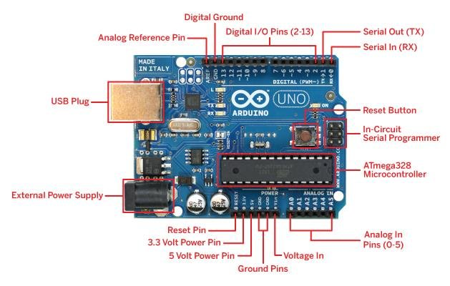

My Project:

The Home Automation System is designed to simplify everyday tasks and enhance the safety of a household. It is powered by an Arduino UNO microcontroller, which processes data from a range of sensors and controls actuators.

**Home Automation System on Tinker cad:**

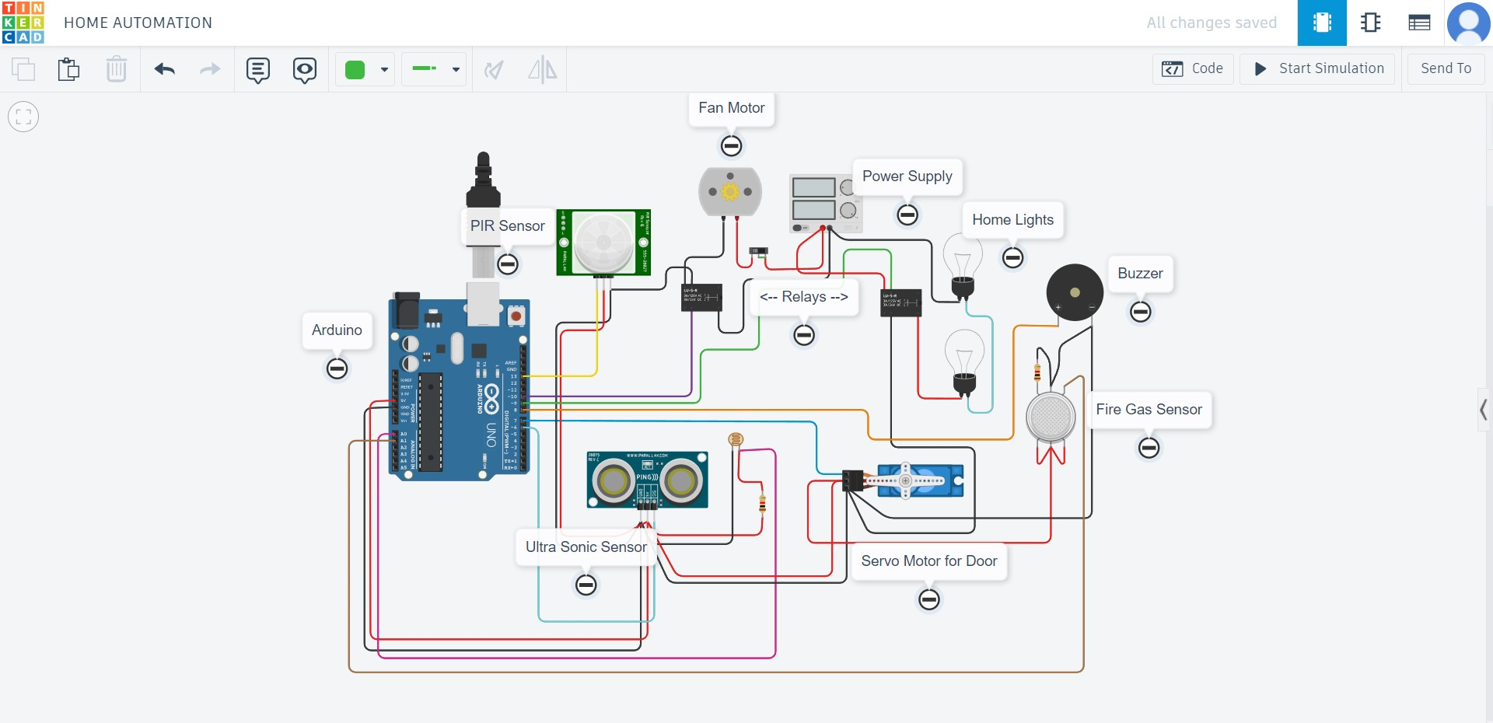

Circuit Diagram:

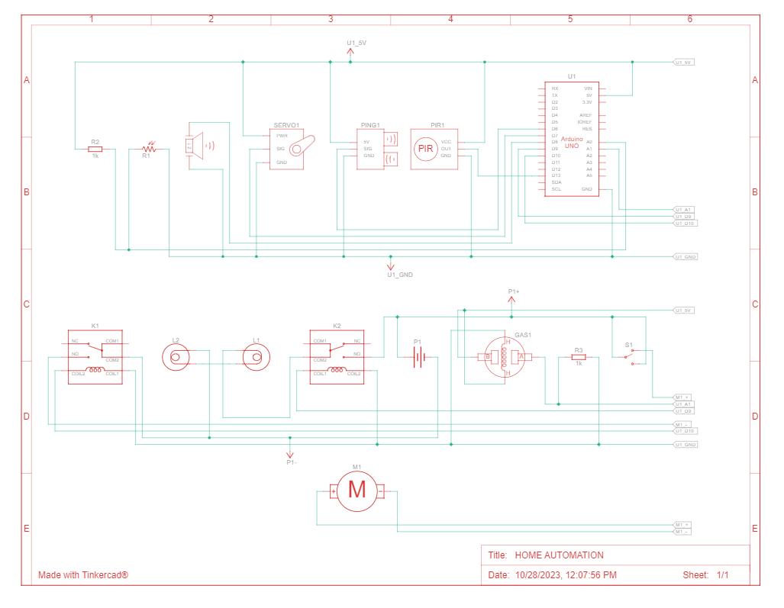

Component List:

|  |  |  |
| --- | --- | --- |
| Description | Label Name | Quantity |
| Arduino Uno R3 | U1 | 1 |
| PIR Sensor | PIR1 | 1 |
| Ultrasonic Distance Sensor | PING1 | 1 |
| DC Motor | M1 | 1 |
| 5, 5 Power Supply | P1 | 1 |
| Gas Sensor | GAS1 | 1 |
| Piezo | PIEZO1 | 1 |
| Positional Micro Servo | SERVO1 | 1 |
| Light bulb | L1, L2 | 2 |
| Relay SPDT | K1, K2 | 2 |
| Photoresistor | R1 | 1 |
| 1 kΩ Resistor | R2, R3 | 2 |
| Slide switch | S1 | 1 |
|  |  |  |

Arduino Code

The project's functionality is achieved through the Arduino code, which is structured into the setup and loop functions. The code utilizes the Servo library for controlling the servo motor and digital/analog pins for sensor readings and actuator control. The code orchestrates the following key functionalities:

#include <Servo.h>

int output1=0;

int sen1value=0;

int sen2value=0;

int const gas_sensor=A1;

int const LDR=A0;

int limit=150;

long readultrasonicdistance(int triggerPin, int echoPin)

{

pinMode(triggerPin,OUTPUT);

digitalWrite(triggerPin,LOW);

delayMicroseconds(2);

digitalWrite(triggerPin,HIGH);

delayMicroseconds(10);

digitalWrite(triggerPin,LOW);

pinMode(echoPin,INPUT);

return pulseIn(echoPin,HIGH);

}

Servo servo_7;

void setup()

{

Serial.begin(9600);

pinMode(A0,INPUT);

pinMode(A1,INPUT);

pinMode(9,OUTPUT);

servo_7.attach(7,500,2500);

pinMode(8,OUTPUT);

pinMode(13,INPUT);

pinMode(10,OUTPUT);

pinMode(4,OUTPUT);

pinMode(3,OUTPUT);

}

void loop()

{

//....light intensity control...//

int val1=analogRead(LDR);

if(val1>500)

{

digitalWrite(9,LOW);

Serial.println("Bulb ON ");

Serial.println(val1);

}

else

{

digitalWrite(9,LOW);

Serial.println("Bulb OFF ");

Serial.println(val1);

}

//.....Light and Fan Control....//

sen2value=digitalRead(13);

if(sen2value==0)

{

digitalWrite(10,LOW);

digitalWrite(4,HIGH);

digitalWrite(3,LOW);

Serial.print("NO MOTION DETECTED");

}

if(sen2value==1)

{

digitalWrite(10,HIGH);

delay(5000);

digitalWrite(4,LOW);

digitalWrite(3,HIGH);

Serial.print("MOTION DETECTED");

}

//......GAS SENSOR...//

int val=analogRead(gas_sensor);

Serial.print("Gas Sensor value");

Serial.print(val);

// val=map(val,300,750,0,1000);

if(val>limit)

{

tone(8,650);

}

delay(300);

noTone(8);

//.....Servo Motor.....//

sen2value=0.01723*readultrasonicdistance(6,6);

if(sen2value<100)

{

servo_7.write(90);

Serial.print("Door open!!; Distance+");

Serial.print(sen2value);

Serial.print("\n");

}

else

{

servo_7.write(0);

Serial.print("Door closed!!; Distance+");

Serial.print(sen2value);

Serial.print("\n");

}

delay(10);

}

**Working Principle:**

To understand how the system functions, here is a detailed explanation of its key features:

* **Light Intensity Control:** The system employs an LDR to monitor ambient light levels. If the light level falls below a predefined threshold (set at 500 in this instance), the system activates a bulb, ensuring adequate illumination. When the light level rises above the threshold, the system turns off the bulb to save energy.
* **Light and Fan Control:** A PIR sensor is used to detect motion within its range. When no motion is detected, the system switches on a fan and one of the bulbs, signifying "NO MOTION DETECTED." However, when motion is detected, the system turns off the fan and the first bulb while turning on a second bulb, indicating "MOTION DETECTED." This ensures energy efficiency and security by illuminating the area only when motion is detected.
* **Gas Sensor:** The system incorporates an analog gas sensor to monitor the air for gas leaks. If the gas level exceeds the predefined limit (set at 150 in this case), a buzzer is activated, alerting occupants to the potential danger.
* **Servo Motor:** An ultrasonic sensor is used to measure the distance to an object. If the distance is less than 100 cm, the system activates a servo motor, which opens a door. The system then reports "Door open!!; Distance+[distance value]." However, if the distance is greater than or equal to 100 cm, the system closes the door and reports "Door closed!!; Distance+[distance value]." This feature enhances home security and offers convenience for automated door control.

**Applications:**

1. **Residential Home Automation:** The primary application is in residential homes. It provides homeowners with enhanced convenience, comfort, and security. It allows for the automation of various tasks, such as lighting control, security, and energy management.
2. **Energy Efficiency:** The system's ability to control lighting based on ambient light levels and motion detection contributes to energy efficiency. Lights are only activated when needed, reducing energy consumption and, subsequently, electricity costs.
3. **Security and Surveillance:** The motion detection feature can be utilized for security and surveillance purposes. When motion is detected, lights can turn on, and homeowners can receive alerts or notifications, enhancing home security.
4. **Door Automation:** The servo-controlled door can be used to automate doors within the home, improving accessibility for individuals with mobility issues. It's also applicable for controlling access to specific areas within the home.
5. **Gas Leak Detection:** The gas sensor can be employed as a safety feature to detect and alert residents to gas leaks, preventing potential accidents and hazards.
6. **Smart Lighting:** The system can be expanded to include more advanced lighting control, such as color-changing LED bulbs and scheduling based on time or user preferences.
7. **IoT Integration:** This project serves as a foundation for a broader IoT (Internet of Things) ecosystem. The sensors and actuators used can be integrated into a larger network, allowing for remote control and monitoring through smartphones or other devices.
8. **Elderly and Disabled Care:** The system can be beneficial for elderly or disabled individuals, allowing them to control their environment more easily. For example, the automated door can provide greater independence for those with limited mobility.
9. **Holiday Home Management:** The system is useful for managing and securing holiday or vacation homes remotely. Homeowners can monitor the property, control lighting, and receive gas leak alerts, improving the overall safety and security of the property.
10. **Educational Purposes:** This project can be used as an educational tool for learning about electronics, Arduino programming, and IoT concepts. It's a hands-on way to teach students about automation and sensor technologies.
11. **Prototyping for Commercial Automation:** The concepts and components used in this project can serve as a prototype or proof of concept for more advanced commercial or industrial automation systems.
12. **Environmental Monitoring:** The system's sensor capabilities can be extended for environmental monitoring. For instance, it can be used to monitor indoor air quality and temperature.

**Conclusion:**

The Home Automation System presented in this project demonstrates the tremendous potential of Arduino-based IoT applications in enhancing the functionality, comfort, and safety of modern homes. It combines various sensors and actuators to automate lighting, motion detection, door control, and gas leak detection. By using Arduino as the central control unit, the project is not only cost-effective but also highly customizable, making it a valuable addition to any household. This project serves as a practical example of how IoT technology can be harnessed to improve the quality of life, energy efficiency, and safety in homes, while also opening doors to further advancements in home automation and IoT.

**Tinkercad link:**

<https://www.tinkercad.com/things/fLdVD8Abfe1?sharecode=bZWgzM9gJUmzTjmZ2hVsbszoeDLmXNDSF5nzhe4EpI0>

**References:**

<https://www.safewise.com/home-security-faq/how-does-home-automation-work/>

<https://home.google.com/welcome/>

<https://www.techtarget.com/iotagenda/definition/smart-home-or-building>

<https://www.researchgate.net/publication/275338025_Home_Automation_Systems_-_A_Study>

<https://www.engpaper.com/ece/home-automation-2021.html>